When the coral disappears, so will they
- This article takes place on an island called Nosy Andragnombala or Andavadoaka off the southwest coast of the island of Madagascar. Draw the island of Madagascar and the island of Nosy Andragnombala in the correct spot off the map of Africa below. Label both islands.
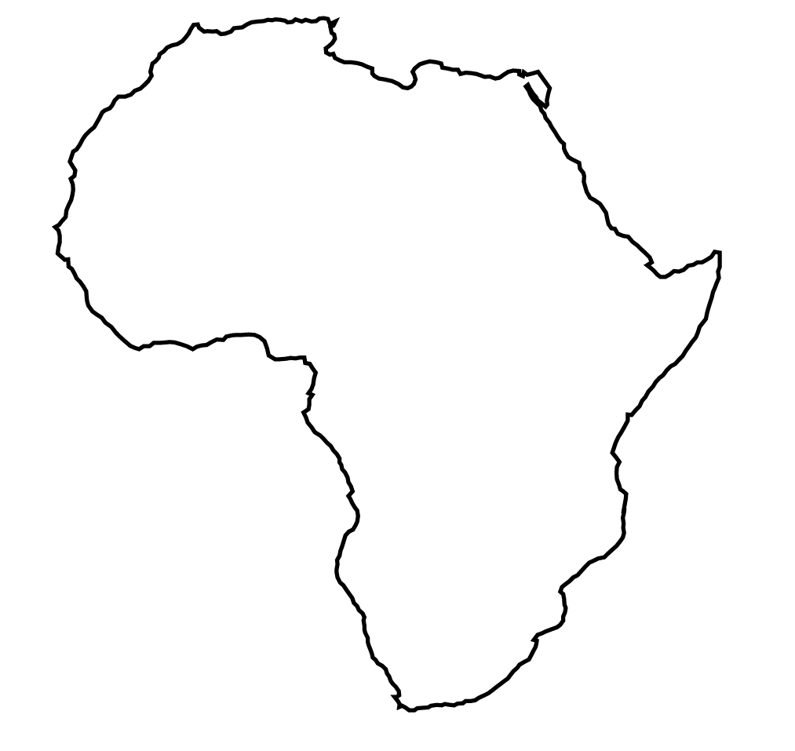
2

- The Vezo People of Madagascar are an indigenous people. What does the word Vezo mean?

- Why are their umbilical cords tossed into the sea at birth?

- How many Vezo People exist in the world today?

- What is the only job for the Vezo People?

- Why is that job in jeopardy for future Vezo People?

- Label the Mozambique Channel on your map above.

- What does the term bleaching mean when used to describe sick coral? BE SPECIFIC

- How do algae benefit coral?

- In how many years from now do scientists think that all the world’s coral reefs could be dead?

- Scientists believe we are on the verge of the 6th mass extinction in history. How many species of animals do scientists think we could loss in the coming centuries?

- Besides climate change, what are two other threats that threaten Madagascar’s coral?

- What does the term bioluminescent mean?

- What have locals done to help protect the reefs on Nosy Andragnombala?

- Why does Lydia only kill large octopus’?

- What is a carbon footprint?

- What is the Paris agreement?

- Coral reefs make up less than 1% of the World’s ocean area. Give me 5 reasons why it is essential to keep coral reefs healthy around the world. Give good evidence.

- Draw a detailed picture of a coral reef below. Label all the life forms you draw on it.

