Name:___________________________________________________________________
Worms
- Worms are classified into three major phylums:
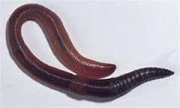
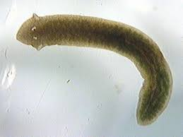
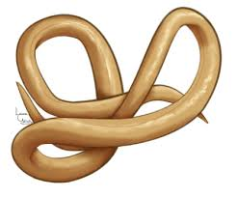

_______________________ _____________________ _______________________
- All Worms:

- Reproduction
Many have separate __________ and _____________ animals, like humans.
Some (most flatworms) have both male and female ________ organs and are known as ___________________.
Some reproduce asexually by breaking into pieces. This is known as ______________.
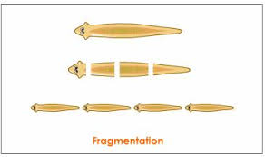

Flatworms
Examples of flatworms are:
1.
2.
3.

Draw a picture of all three in the boxes below.

- Common Characteristics:

- Planarians
- Free-living flatworms
- Live in the water
Planarians are _______________________ that feed on dead or decaying material. They can be _____________________. They feed like a vacuum cleaner. They insert a feeding tube into prey, juices break down the prey and they suck up the partly digested food.
They have _____________ that can detect light but not detail.
Their head has cells than can pick up odor so that they can locate ____________.
- Tapeworms

Roundworms
- Live in nearly any __________ environment
- Tiny and difficult to see, most ___________ animal on earth
- Some are free-living and some are ________________
- Cylindrical bodies – like tiny strands of cooked spaghetti
- Digestive system is like a tube, open and both ends
  - Food enters the _________
  - Food is broken down by digestive juices
  - Digested food is absorbed by the body
  - Waste material exits at the far end of the tube called the _________
Segmented Worms
Examples of segmented worms: _________________, _________________, ____________
- Made up of many linked sections called ________________
- Have a long string of ______________ tissue called a nerve cord
- ____________________ tube runs the length of the body
Circulatory System
- Have a closed circulatory system – ___________ moves only within a connected network of tubes called blood vessels.
- Blood carries _______________ and food to cells
- Moves blood much more ________________

