Name:________________________________________________Date:_______________
Fish Research Template
PART 1 RESEARCH
Fish Type: Jawless, Cartilaginous, Bony or Wisconsin Fish
Scientific Name:
Common Name: (There may be more than one)
Origin of Name:

- Ocean, Brackish or Freshwater fish:
- Where in the world do you find them: (mark all locations)
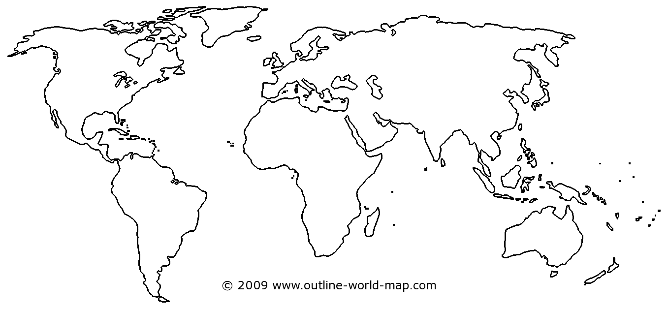

- Describe in words where they live in the world.

- How long have they inhabited the earth:
- What kind of coloring do they have and why:

- Sketch and color a picture of the fish below.

- Does their coloring or appearance change depending on where they are found in the world?

- What unique body features do they have that help them to survive: (use must have at least 3)

- What is their average:
Length:(in inches or feet) Female: Male:
Weight:(in ounces or pounds) Female Male:
Are females or males larger?
- Is there a size limit (minimum or maximum) if people fish for them?

- If your fish is caught by people, what is the biggest ever caught on record and where was it caught?

- How long do they live on average?
- How do they reproduce: Sexually or Asexually Internal or External Fertilization
At which age do females and males mature sexually?
Female: Male:
- Where and when do they spawn? Explain in detail. Some may give live birth, explain this as well.

- How long does it take for eggs to hatch or offspring to be born alive?

- Is there any parenting that occurs before or after offspring are born?

- What do they eat?

- What eats them?

- Are there any threats to this fish?
- Do they have an economic impact:

- Are they used for human recreation:

- Are they found anywhere in human culture:

- Do they form social groups:

- Interesting facts about the fish:

PART 2 LIMERICK
Using what you have learned about your fish, you will write a limerick poem using the information you’ve found.

What is a Limerick?
Limericks are one of the most fun and well-known poetic forms. No one knows for sure where the name “limerick” comes from, but most people assume it is related to the county of Limerick, in Ireland.
The reason limericks are so much fun is because they are short, rhyming, funny, and have a bouncy rhythm that makes them easy to memorize.

The Rules of Limericks
Limericks, like all poetic forms, have a set of rules that you need to follow. The rules for a limerick are fairly simple:
- They are five lines long.
- Lines 1, 2, and 5 rhyme with one another.
- Lines 3 and 4 rhyme with each other.
- They have a rhythm that sounds good when said out loud.
- They are usually funny.

Rhyming a Limerick
The rhyme scheme of a limerick is known as “AABBA.” This is because the last words in lines 1, 2, and 5 rhyme. Those are the “A’s” in the rhyme scheme. The “B’s” are the last words of lines 3 and 4. Let me give you an example:
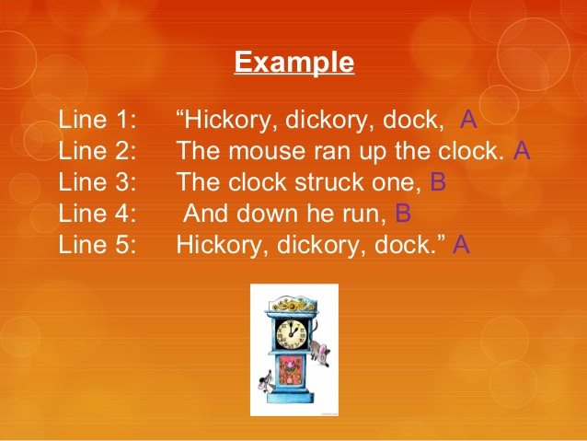
Write you limerick below:
Line 1
Line 2
Line 3
Line4
Line 5

Part 3 Recycled Fish
- Using the cardboard provided by your teacher, trace and cut out the shape of you fish.
- Decorate your cardboard fish using recycled materials to recreate colors and textures found on your fish.

- You may not color the fish, you must only use glued on materials such as corks, bottle caps, scrap paper, etc.

