Fish
Learning Target:

There are 7 groups of vertebrates:

Only ______% of the animals on earth are vertebrates. Most vertebrates on earth are fish. There are more than _____________ species of fish, ranging in size from tiny minnows to whale sharks. Fish live in nearly every aquatic environment, from ________________ lakes to ______________ water and the bottom of the sea.
Most bony fish have fins with different functions. Their bodies are designed for moving _______________ through water. They have ________________ to support muscles and surround the _______________ cord, which connects the animal's ______________ to its nerves. Other bones, such as the __________ and ____________, protect organs like the heart, lungs and brain.
Fish have ___________ to remove oxygen from the water. Fish gills are made up of many __________ of tissue and are filled with blood. A ______________ that allows fish to sense objects and organisms that are nearby by using vibrations. Fish have __________________that allow the fish to adjust how high or low the fish floats.

There are three types of fish:
Jawless Fish: This group includes ____________ and ____________. Jawless fish are believed to be the first fish on earth. They have simpler bodies than other fish. They do not have a _____________. They do have teeth but they cannot chew.

Cartilaginous Fish: This group includes ____________, _________, and ___________. Their skeletons are not made of hard bone, but of a flexible tissue called __________________.
Bony Fish: Most fish species, including tuna, flounder, goldfish, and eels, are classified in this large, diverse group. Of the 20,000 fish species, about 96 percent are bony fish. Bony fish have skeletons made of hard bone. Most bony fish have ___________, __________, and ______________ and several pairs of _____________.

Label the following items on the large-mouth bass below.
- ​Spiny Dorsal Fin
- Soft Dorsal Fin
- Anal Fin
- Pelvic Fin
- Pectoral Fin
- Caudal Fin
- Operculum
- Lateral Line
- Maxilla
- Mandible

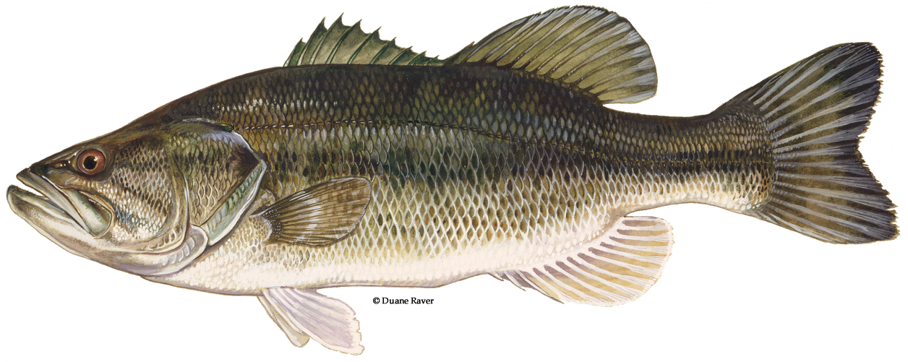

Most fish reproduce ________________. The female produces eggs, and the male fertilizes them ___________________ with sperm. After the eggs are fertilized, the parent fish usually leaves the eggs to develop and hatch on their own. Most fish eggs are surrounded by a soft egg case that _________________can pass through. Since fish lay eggs in the water, this means that a fish _________________ inside an egg gets the water and oxygen it needs directly from its surroundings. The egg's _______________ provides the developing fish ___________. Fish often lay and fertilize many eggs, but with no ________________, few of them survive to maturity.

