Growth of Organisms
Directions: Each student will be assigned a number and a corresponding organism to research. Use the template provided below to answer the questions about your organisms growth.
- Resurrection plant
- Brine shrimp
- Snapping shrimp
- Easter egg plant
- Mimosa pudica
- Portuguese man-o-war
- Caulerpa
- Slime mold
- Scout bees
- Volvox
- Shetland sheepdog
- Raven
- Dolphin
- Acquatic rat
- Dingo
- Chinchilla
- Hyrax
- Wheat
- Pine marten
- Starfish
- Nematode
- Broccoli
- Mosquito
- Jack jumper ant
- Kamraj
- Narcondam Hornbill
- Oceanic Whitetip Shark
- Owston's Banded Palm Civet
- Pale Lilliput Pearlymussel
- Saw-billed Hermit
Name:_________________________________________________Date:____________________
Growth of Organisms
Organism Name:__________________________________________________________________
- Draw and label a model of your organisms life cycle below.
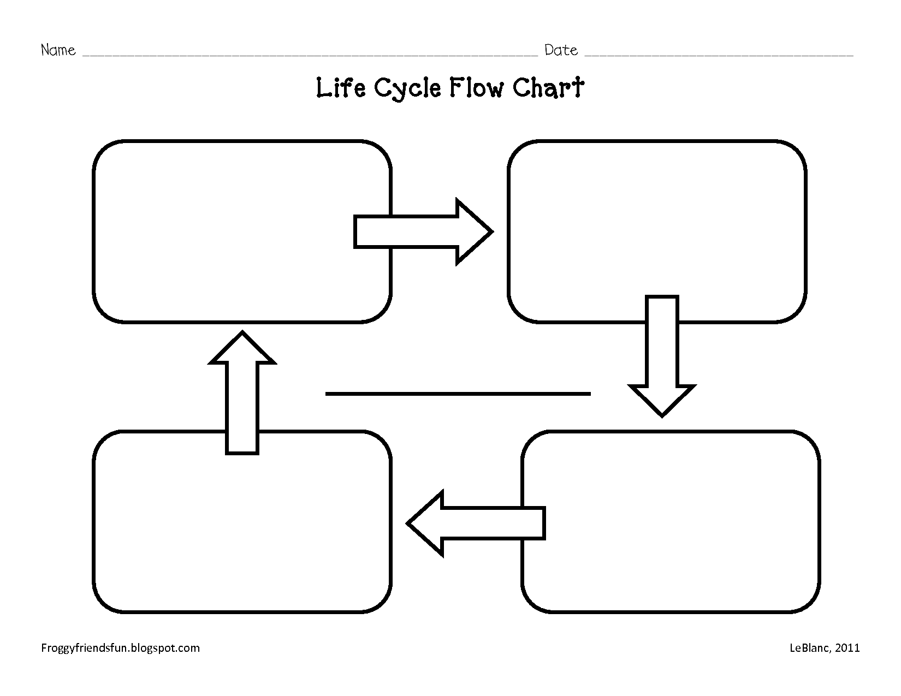

- Describe the size of your organism at the various stages of its life cycle. For example, a human would be infant, toddler, teen, adult. What are the average sizes of a male/female.

- At what age does your organism reach sexual maturity? Meaning…at what age can they reproduce?

- How many offspring on average does your organism have?

- How often do they reproduce?

- What is the organsims average life span?

- Any other amazing facts about your organism?

