Cnidarians

Cnidarians include corals, jellyfish, sea anemones, and hydra. Jellyfish are fish-eating animals that float in the sea - only a few jellyfish live in fresh water. They have soft bodies and long, stinging, poisonous tentacles that they use to catch fish. Label and color the tentacles green. The tentacles hang down from an umbrella-shaped medusa. Label the medusa. The jellyfish has two cell layers --- an outer ectoderm and an inner endoderm. Label and color the ectoderm red and the endoderm orange. Between these layers is a jellylike material called mesoglea. Label and color the mesoglea pink. The mouth is located on the underside in the center of the tentacles. Label the mouth. The mouth opens into the gastrovascular cavity where their prey is digested. Label and color the gastrovascular cavity tan.
Venom or a paralyzing poison is sent out through stinging cells called cnidocytes. Label and color the cnidocyte yellow. Inside the cnidocytes, is a coiled, poisonous thread that can shoot out to paralyze prey with poison. This harpoon-like structure is called the nematocyst. Cnidocytes have a trigger that when touched shoot out the nematocyst. Label and color the nematocyst orange. Label the trigger on the cnidocyte.
Jellyfish go through two stages in their life cycle --- polyp and medusa. The adult jellyfish has tentacles hanging downward and is called the medusa stage. Label and color the adult medusa stage red. Eggs and sperm are released into the water and join to form a fertilized egg or zygote. Color and label the zygote yellow. The zygote goes through multiple cell divisions to form a free-swimming, ciliated larval stage. The larva is called the Planula. Color and label the Planula orange. The Planula larva swims and feeds for many months during the winter before it settles to the bottom, attaches, and forms the next stage in the life cycle known as the polyp stage. Color and label the polyp green. This small polyp grows during the spring and forms linking tubes with polyp buds. This is called the polyp hydroid colony. Label this colony. Color and label the tubes dark green and the buds pink. The buds break off in late spring and become new jellyfish. Label and color one of the new jellyfish light blue.
Another common cnidarian is the hydra found mainly in freshwater. The hydra only exists in the polyp, not the medusa stage. Polyps have upright tentacles with their mouth located on the top. Label the mouth on the hydra. Color and label the tentacles light green and the body that the tentacles are attached to dark green. Hydras have a base that can produce a sticky material that they use to attach to surfaces. Whenever a hydra wants to move, it bends over and somersaults using its tentacles. MAKE A SKETCH OF A HYDRA SOMERSAULTING!
Hydras can reproduce by sexual reproduction. Hydras have testes to produce and release sperm and ovaries to produce and release eggs. Color and label the testes on the first hydra in Figure 6 brown. Label the released sperm. Color and label the ovaries on the second hydra orange. Fertilization occurs in the water and forms a fertilized egg or larva. Color and label the fertilized egg or zygote red. This zygote develops into a free-swimming Planula larva. Color and label the Planula larva dark blue. Eventually the Planula settles to the bottom and develops into an adult hydra. Buds may develop on the hydra that can break off and form more new hydras asexually. This asexual process of reproduction is called budding. Color and label the buds pink. Color and label the adult hydra yellow.
Another marine cnidarian is the sea anemone. The sea anemone, like all cnidarians, has radial symmetry. Radial symmetry is the arrangement of parts about a central point. Adult sea anemones exist in the polyp stage. Their upright tentacles not only help them catch their prey with nematocysts, but also serve as a home for some fish such as the clown fish (Nemo). Color and label the tentacles yellow and the body orange. The mouth is also located at the top and opens into the gastrovascular cavity. Label the mouth on figure 7.
Figure 1 - Jellyfish
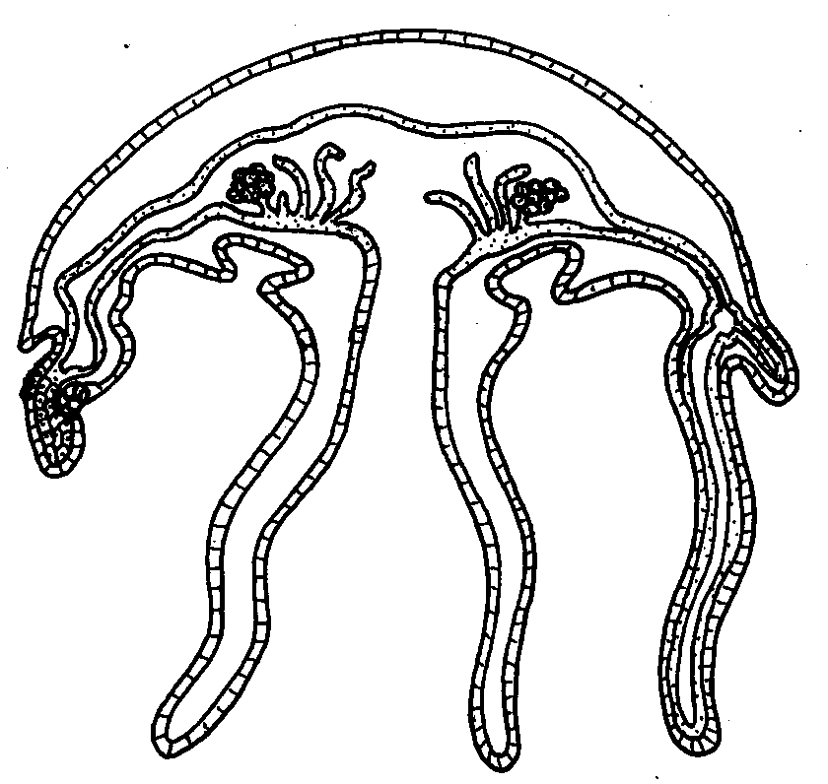

Figure 2 - Cnidocytes | Figure 3 - Nematocyst
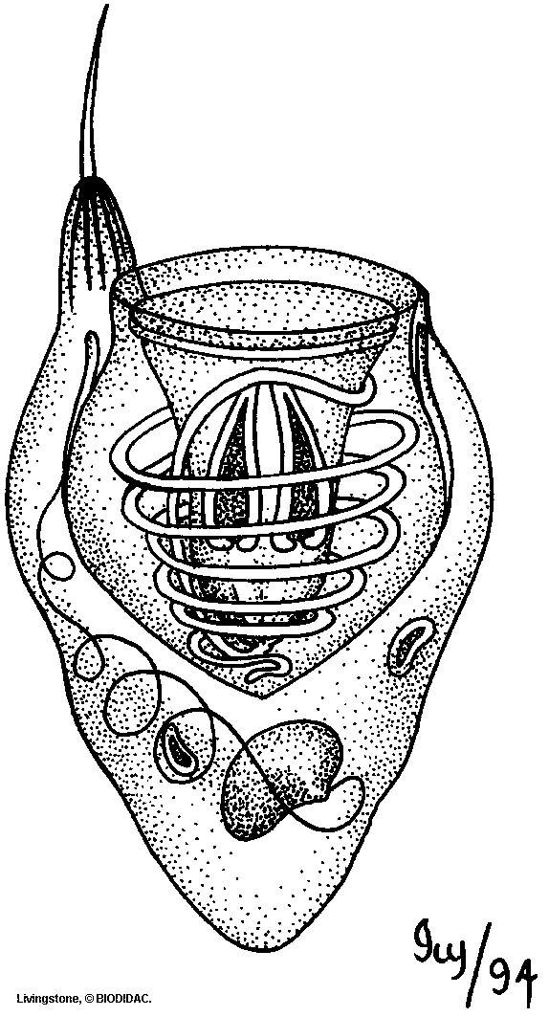 | 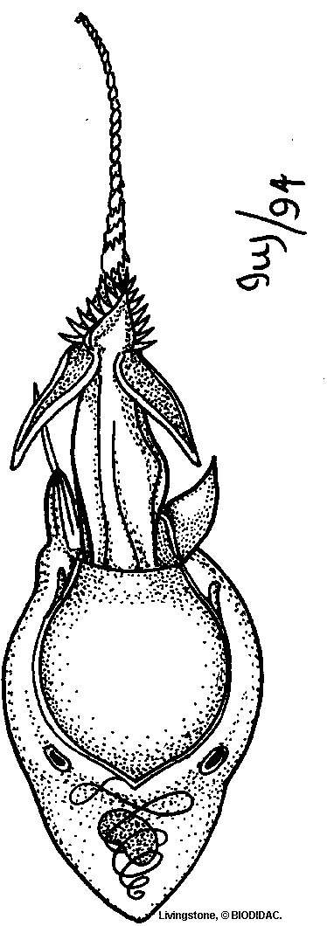

Figure 4 – Life Cycle

Figure 5 - Hydra
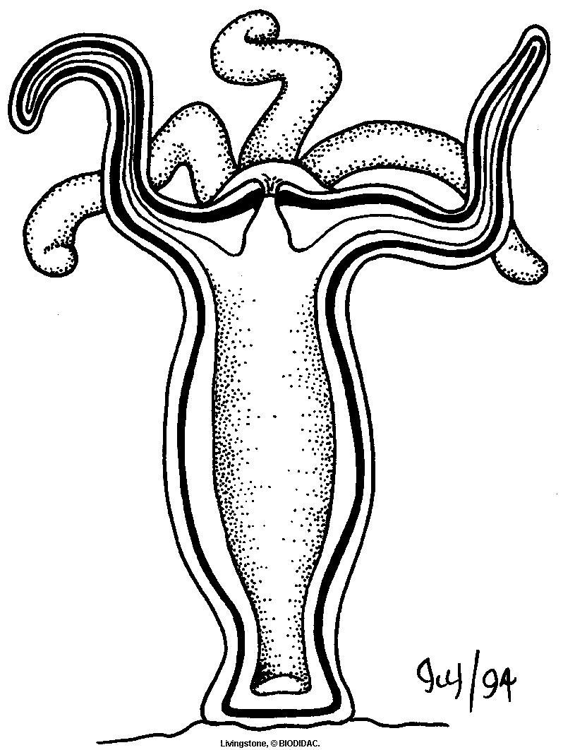

Sketch of Somersaulting Hydra
Figure 6 – Hydra Life Cycle
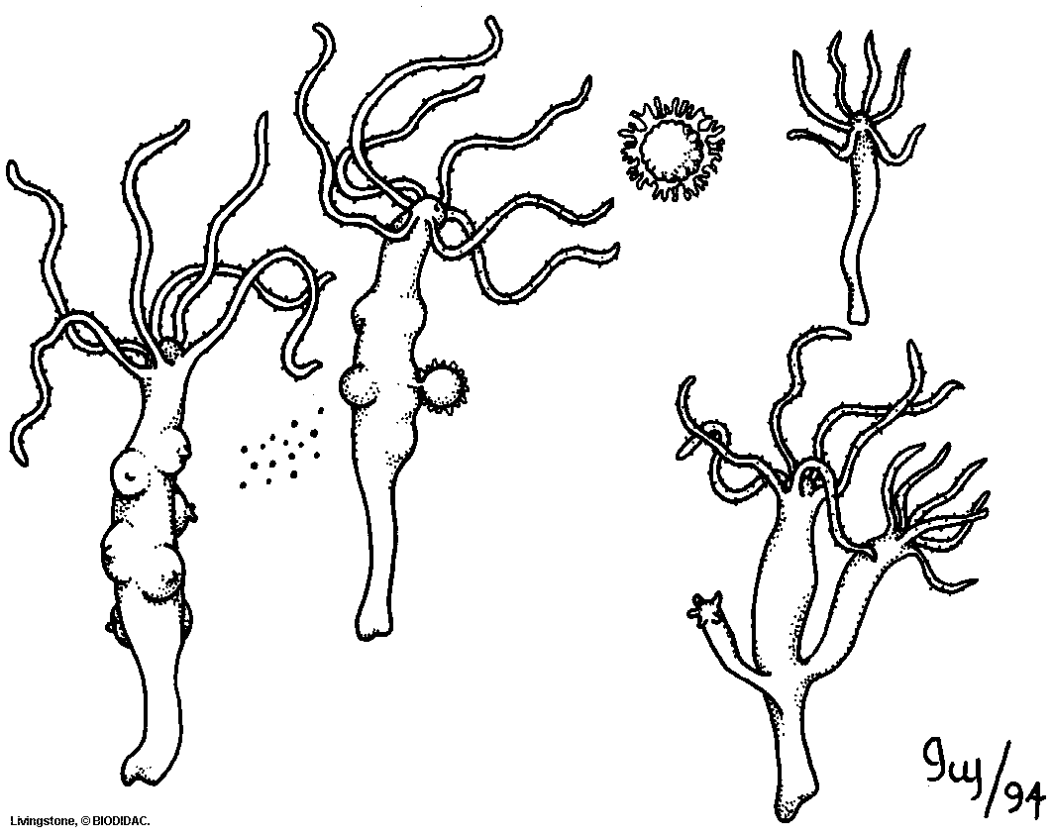

Figure 7 – Sea Anemone
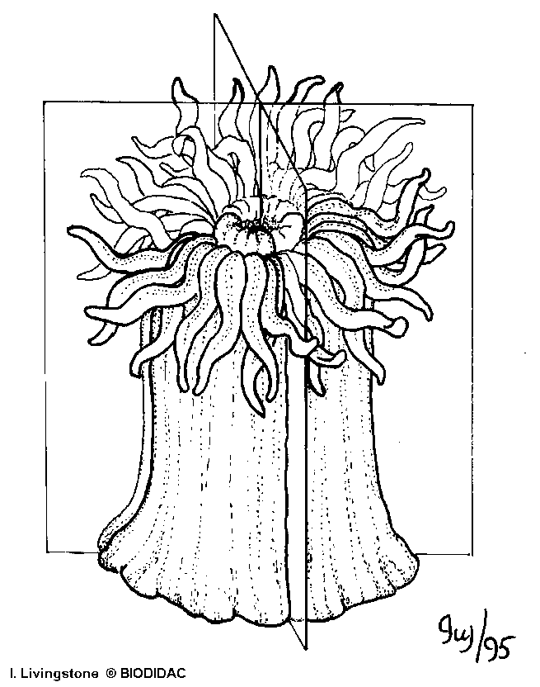

Questions:
1. How many germ layers do cnidarians have and name them.

2. What are the two body forms of cnidarians and make a sketch of each.

3. What specialized cells do cnidarians use for protection?

4. Explain how a nematocyst works.

5. How many body openings do cnidarians have?
6. What does the mouth of the cnidarian open into?

7. What is the effect of the poison produced by cnidarians on their prey?
8. Explain the jellyfish life cycle.

9. How do hydras reproduce asexually?

10. What is the larva of a cnidarian called? How does it move?

11. Explain how the adult hydra attaches to feed?

12. What type of symmetry do cnidarians have?

13. How do hydras feed?

