Classifying Sharks using a Dichotomous Key

A classification system is a way of separating a large group of closely related organisms into smaller subgroups. With such a system, identification of an organism is easy. The scientific names of organisms are based on the classification systems of living organisms.

To classify an organism, scientists often use a dichotomous key. A dichotomous key is a listing of specific characteristics, such as structure and behavior, in such a way that an organism can be identified through a process of elimination.

In this investigation, it is expected that you:

- Use a key to identify 14 shark families.
- Study the method used in phrasing statements in a key.

Procedure

- Read sentences 1A and 1B of the key. Then study shark 1 in figure A for the characteristics referred to in 1A and 1B. Follow the directions in these sentences and continue with this process until a family name for Shark 1 is determined.

For example, if the shark has an anal fin, and its body is not kite shaped, following the directions of 1A and go directly to sentence 2. If the shark lacks and anal fin or has a kite shaped body, follow the directions of 1B and go to sentence 10.

- Continue this process with each shark until all animals have been identified. Write the family name on the line below each animal.

- Use figure 1 as a guide to the anatomical features used in the key.

Figure 1 – Anatomy of a Shark
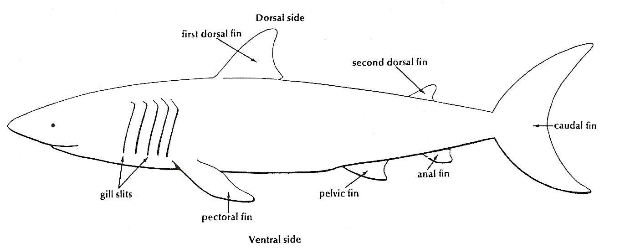
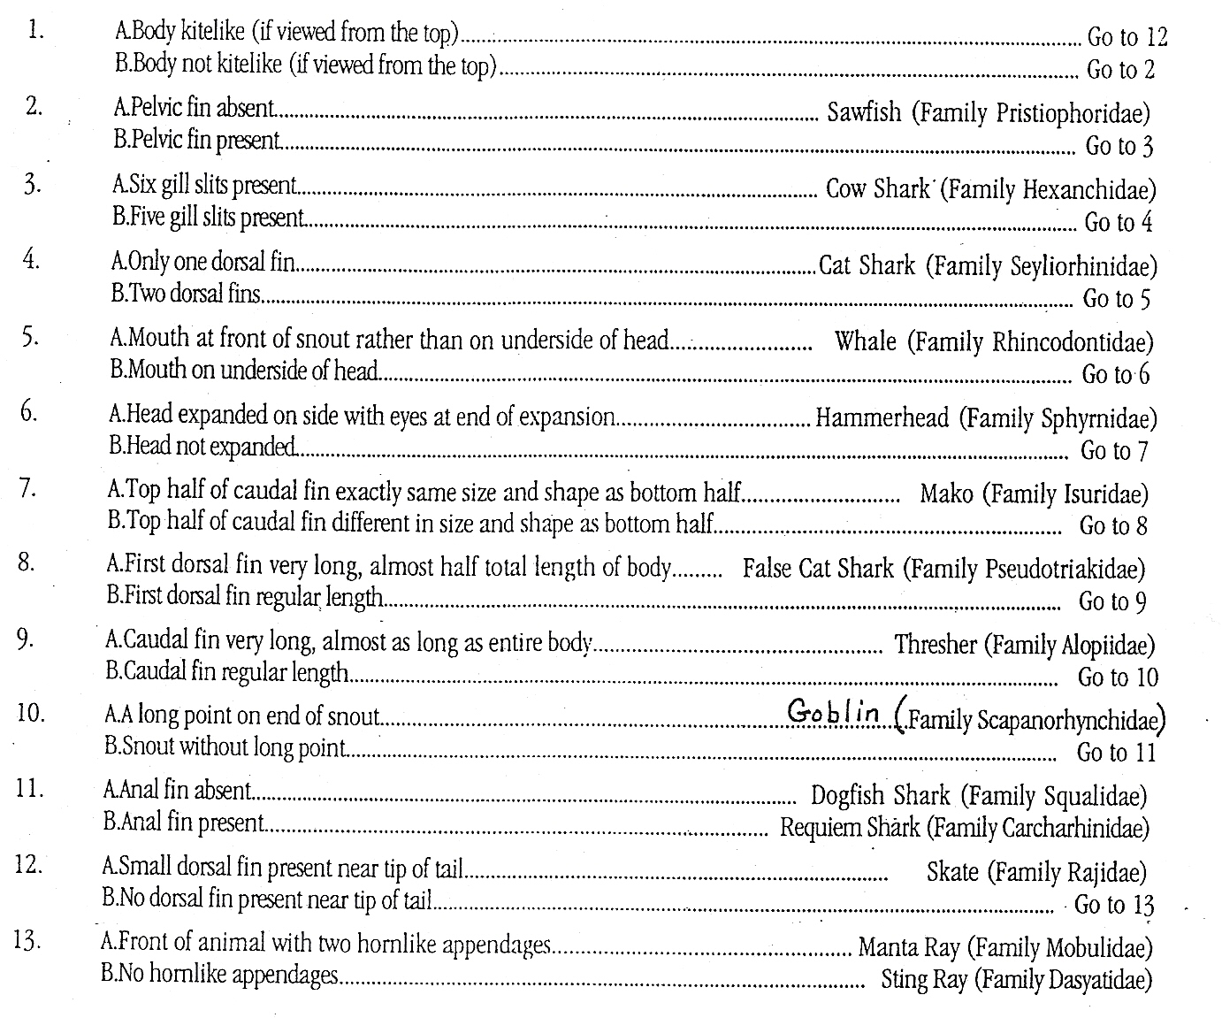
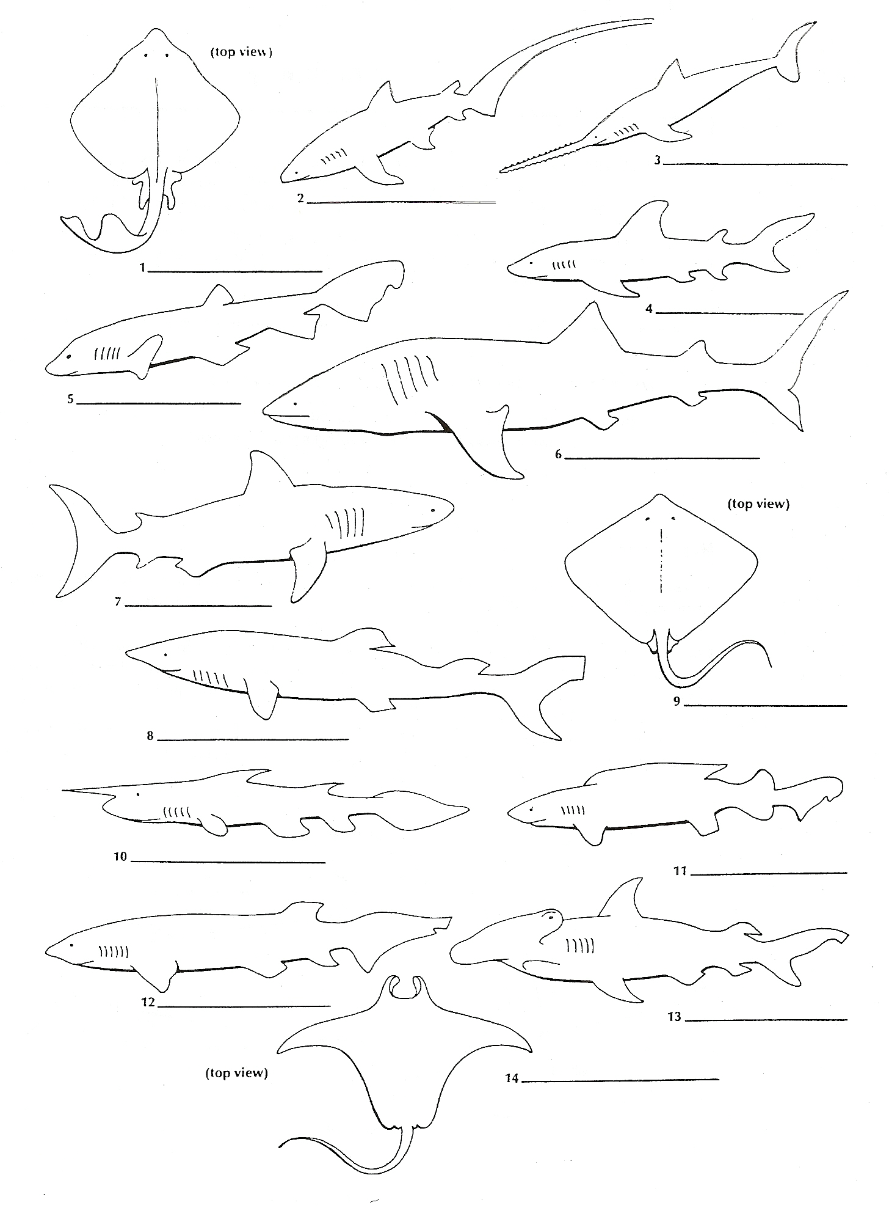
Key to Shark Identification

Shark Answer Key
1. Skate
2. Thresher shark
3. Sawfish
4. Mako shark
5. Cat shark
6. Whale shark
7. Requiem shark
8. Dogfish
9. Sting Ray
10. Goblin shark
11. False Cat shark
12. Cow shark
13. Hammerhead shark
14. Manta Ray

