Name:_________________________________________________Date:______________
Lesson 1.3
1.
Learning Target:

1. Review
1.
2.
3.
2. What is a virus? How does it compare in size to bacteria?
3. Scientists have learned much about viruses, and can even make images of them with specialized microscopes. Viruses consist of genetic material contained inside a protective protein coat called a _____________________. The protein coat may be a simple tube, such as the coat of an Ebola virus, or have many layers, such as the smallpox virus.
Viruses come in many shapes and sizes, but all viruses consist of a capsid and __________ material. Viruses are able to use living cells to get their DNA copied and so can produce new viruses, a characteristic that makes them similar to living things. Also the protein coat is similar to a cell’s outer membrane. But viruses do not grow, and viruses do not respond to changes in their environment. Therefore, viruses are not living organisms.
Similarities to living organisms (list 2) Differences to living organisms. (list 2)

1.

2.

4. Draw and label the two main parts of a virus below.

5. Viruses cannot reproduce by themselves. However, viruses use materials within living cells to make copies of themselves. The cells that viruses infect in order to make copies are called ________ cells. Despite their tiny size, viruses have the ability to cause a lot of damage to cells of other organisms. One of the best studied viruses infects bacteria cells. The steps that the virus goes through to multiply are drawn below.

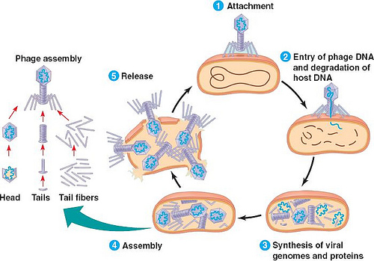

Describe each of the 5 phases of virus replication below.
- Attachment:
- Injection:
- Production:
- Assembly:
- Release:

- Viruses may harm host cells and can cause major death and damage.

Viruses that have caused widespread death are polio, smallpox, and AIDS. About 25 million people died of influenza in an outbreak that occurred just after World War I.
Plant viruses can stunt plant growth and kill plants. When plant viruses invade crop plants, they can cause much economic damage and decrease food productions.

