Name:_________________________________________________Date:______________
Lesson 1.2
1.
Learning Target:

1. Review
1.
2.
3.

2. What are bacteria?
1.
2.
3.

3. Label the bacteria cell below.
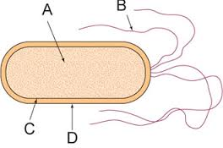
A.
B.
C.
D.

4. Scientists classify bacteria by their external shapes. (Draw the shapes below)

Spiral Bacteria Rod Bacteria Round Bacteria
5. Archaea is single-celled organisms that can survive in the largest range of _____________.
These environments may be very hot, very cold, or contain so much of a substance such as salt that most living things would be poisoned. As a result, scientists group archaea according to where they live.
6. Describe the three types of archaea.
Methanogens:

Halophiles:

Thermophiles:
7. Bacteria are grouped by the roles they play in the environment.
Bacteria that transform energy from sunlight into energy that can be used by cells are called __________________.
_____________________get energy by breaking down materials in dead or decaying organisms. They help other organisms reuse materials found in decaying matter.
Some bacteria live in a very close relationship wither inside or on the surface of other organisms. Some of these bacteria may have no effect on their host organisms or host cells. Some bacteria help their hosts. Other bacteria are _________________, organisms that harm their hosts.
8. Bacteria can be good and bacteria can be bad. List 3 good bacteria and 3 bad bacteria.

