Name:________________________________________Date:__________________
Learning Target:

- An organism is a __________________ thing.
- Brainstorm and come up with 5 large organisms and 5 small organisms.

Small Large
1. 1.
2. 2.
3. 3.
4. 4.
5. 5.

- Very small organisms are called ____________________________.
The word _____________ means “very small”.
A single drop of water from the Mullet River may be the living space for many ____________________.
Research and use the wheel diagram to list attributes of the answer to question 2.
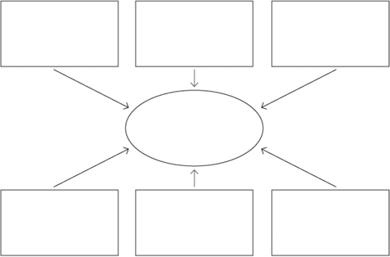

- Scientists have divided all of the organisms on earth into 6 groups called kingdoms. Research and list the 6 kingdoms below.

- All living things share 4 common characteristics. They are easily remembered by the acronym OGRE. Identify each characteristic below.
  - O
  - G
  - R
  - E
- What is binary fission?

- What 3 things do all living things need?

- What is a virus? Is it a living thing? Why or why not?

- Your favorite animal is a _____________________? Research your animal and give examples of how it is organized, grows, responds to its’ environment, and reproduces.

